Construction Planning Assistant Agent Report

  - Course Name: Agentic AI

Institution Name: Medicaps University – Datagami Skill Based Course

Student Name(s) & Enrolment Number(s):
Sr no | Student Name | Enrolment Number
01. | PALAK HARDE | EN22CS301673
02. | PARIKSHIT GOLE | EN22CS301685
03. | NITIN KUMAR SINGH | EN22CS301662
04. | NITISH SINGH YADAV | EN22CS301663
05. | PRIYAL GUPTA | EN22CS301619

Group Name: Group 07D6
Project Number: AAI-18
Industry Mentor Name:
University Mentor Name: Nishant Shrivastava
Academic Year: 2025-2026

Problem Statement & Objectives

Problem Statement

Project Objectives

Scope of the Project

Proposed Solution
- Key features (Just mention key features here no need to go into details)
- Overall Architecture / Workflow
- Tools & Technologies Used (If applicable)

Results & Output
Add the below details here:
- Screenshots / outputs
- Reports / dashboards / models
- Key outcomes

Conclusion
Mention a brief conclusion about your project summing up everything you have worked on and the key learning.

Future Scope & Enhancements

Problem Statement & Objectives
1. Problem Statement
Construction project planning is one of the most critical phases in the lifecycle of any infrastructure development activity. It involves breaking down a complex project into manageable tasks, arranging them in a logical sequence, allocating resources, and estimating timelines. However, in real-world scenarios, this process is largely manual and highly dependent on human expertise and experience.
Challenges in Traditional Construction Planning
Traditional planning methods face several practical and technical limitations:
1.1 Manual Planning Complexity
• Planning requires detailed understanding of construction processes.
• Engineers must manually identify tasks, dependencies, and durations.
• Large projects may contain hundreds of interdependent activities.
• Manual decomposition increases cognitive load on planners.
1.2 High Risk of Human Error
• Incorrect task sequencing can delay the entire project.
• Missing dependencies can create execution conflicts.
• Misjudgment of resource requirements leads to unrealistic plans.
• Human planners may overlook minor but critical activities.
1.3 Lack of Intelligent Automation
• Existing tools mainly provide static scheduling features.
• They require manual task input instead of generating tasks automatically.
• No intelligent system exists to understand high-level project goals.
• Traditional software cannot perform reasoning or decision-making.
1.4 Difficulty in Converting Goals into Plans
• Users typically describe projects at a high level (e.g., “build foundation”).
• Translating such goals into actionable tasks requires expertise.
• The process is time-consuming and inconsistent.
1.5 Resource Management Challenges
• Resource availability must be checked manually.
• Over-allocation of resources is a common issue.
• Planners may not accurately estimate labor or material requirements.

1.6 Inefficient Scheduling
• Scheduling is often done using trial-and-error methods.
• Dependencies and resource conflicts complicate timeline creation.
• Lack of optimization leads to longer project durations.
1.7 Limited Adaptability
• Manual plans are difficult to modify when conditions change.
• Planners must redo significant portions of the work.
• Traditional systems lack dynamic adaptability.
1.8 Need for an Intelligent Solution
Considering these challenges, there is a clear requirement for a system that can:
• Understand construction goals automatically
• Break them into structured tasks
• Validate feasibility using logical rules
• Generate optimized schedules
• Reduce human effort while improving accuracy
This need motivated the development of the Construction Planning Assistant Agent, which combines AI reasoning with deterministic validation to automate construction planning.

2. Project Objectives
The project aims to design and implement an intelligent system capable of automating the planning phase of construction projects.
2.1 Primary Objectives
• To develop an AI-assisted system for automated construction planning.
• To convert high-level project goals into structured execution plans.
• To reduce dependency on manual planning processes.
2.2 Functional Objectives
• To accept construction goals in natural language format.
• To decompose complex objectives into smaller tasks automatically.
• To identify dependencies between tasks.

• To validate task sequencing logically.
• To ensure resource feasibility for each task.
• To generate a realistic and optimized project timeline.
2.3 Technical Objectives
• To integrate AI reasoning using Large Language Models.
• To implement rule-based validation for reliability.
• To design modular architecture for scalability.
• To maintain structured data flow across components.
• To ensure secure API communication.
2.4 Performance Objectives
• To minimize planning time compared to manual methods.
• To reduce scheduling conflicts.
• To ensure fast processing using in-memory operations.
2.5 Usability Objectives
• To provide a simple and user-friendly interface.
• To generate easy-to-understand execution plans.
• To enable quick planning without expert intervention.

3. Scope of the Project
The scope defines the boundaries and capabilities of the system.
3.1 In-Scope Features
The project covers the following functionalities:
Task Planning
• Automatic task decomposition from construction goals.
• Identification of task relationships and dependencies.
Validation Mechanisms
• Dependency correctness verification.
• Resource availability checking.
Scheduling
• Automatic timeline generation.
• Resource conflict prevention.

Plan Generation
• Structured output display.
• Execution sequence visualization.
3.2 System Boundaries
The system focuses only on the planning phase and does not cover full project execution.
3.3 Out-of-Scope Features
The following features are not included:
• Real-time construction monitoring
• Dynamic resource tracking
• Financial cost estimation
• Risk assessment modules
• Multi-user collaboration support
• Persistent database storage
• Integration with external construction management systems
3.4 Target Users
The system is intended for:
• Civil engineers
• Construction planners
• Project managers
• Academic researchers
• Students learning construction management
3.5 Assumptions
• Resource data is predefined and static.
• Each planning request is independent.
• Input goals are related to construction activities.
• The system operates in a controlled environment.

Proposed Solution
1. Introduction to the Proposed Solution
The Construction Planning Assistant Agent is designed as an intelligent, automated system that simplifies the complex process of construction project planning. The

solution combines Artificial Intelligence with rule-based validation techniques to generate realistic and optimized construction plans.
Unlike traditional planning tools that require manual task entry and sequencing, this system can understand high-level construction objectives provided by the user and automatically convert them into structured execution plans. The system ensures that all generated plans are logically correct, resource-feasible, and efficiently scheduled.
The proposed solution focuses on bridging the gap between AI-based reasoning and practical engineering constraints. It achieves this by separating intelligent planning tasks from deterministic validation processes.

2. Key Features of the Proposed System
The Construction Planning Assistant Agent provides several innovative features that enhance planning efficiency and accuracy.
2.1 Intelligent Task Decomposition
• The system can interpret high-level construction goals written in natural language.
• It automatically breaks down complex objectives into smaller actionable tasks.
• Tasks include estimated duration, required resources, and dependencies.
• Eliminates the need for manual task identification.
2.2 AI-Assisted Planning Capability
• The system uses a Large Language Model for intelligent reasoning.
• It can understand construction context and planning logic.
• AI helps in generating realistic and structured task workflows.
2.3 Dependency Validation Mechanism
• Ensures correct execution order of tasks.
• Detects circular dependencies automatically.
• Prevents tasks from starting before prerequisites are completed.
• Maintains structural integrity of the construction workflow.
2.4 Resource Feasibility Checking
• Validates availability of labor, equipment, and materials.
• Prevents unrealistic scheduling due to resource shortages.
• Ensures practical feasibility of generated plans.
2.5 Automated Scheduling System

• Assigns start and end times to each task.
• Considers dependencies and resource constraints.
• Minimizes overall project duration.
• Avoids resource conflicts.
2.6 Modular System Architecture
• System components are independent and loosely coupled.
• Allows easy maintenance and scalability.
• Supports future integration of new modules.
2.7 Structured Plan Generation
• Final output is organized in a readable format.
• Includes task sequence, timeline, and resource details.
• Easy to interpret by engineers and project managers.

3. Overall Architecture of the System
The system follows a modular, layered architecture that separates AI reasoning from deterministic validation components.
3.1 Architecture Overview
The architecture consists of the following major components:
• User Interface Module
• Planning Agent (Core Controller)
• Large Language Model Integration Layer
• Task Structuring Module
• Dependency Checking Module
• Resource Validation Module
• Scheduling Module
Each component performs a specific function and communicates through structured data.
3.2 User Interface Component
The User Interface serves as the interaction point between the user and the system.
Responsibilities:

• Accepts high-level construction goals from the user.
• Displays generated execution plans.
• Provides simple and user-friendly interaction.
Characteristics:
• Does not perform planning logic.
• Focuses only on input and output handling.
3.3 Planning Agent (Core Logic Layer)
The Planning Agent acts as the central coordinator of the system.
Functions:
• Receives user input from the interface.
• Converts input into structured prompt format.
• Communicates with the Large Language Model.
• Ensures structured output formatting.
• Coordinates workflow between modules.
3.4 AI Integration Component
This component manages interaction with the Large Language Model.
Key Roles:
• Sends prompts to the AI system.
• Receives decomposed task data.
• Handles API authentication and communication.
• Ensures structured response format.
3.5 Task Structuring Module
This module processes AI-generated outputs.
Responsibilities:
• Converts AI text into structured task objects.
• Assigns unique task IDs.
• Stores duration, dependencies, and resource details.
• Ensures data consistency.
3.6 Dependency Checking Module
This module ensures logical correctness of tasks.

Functions:
• Verifies task sequencing.
• Detects circular dependencies.
• Ensures prerequisite completion before execution.
• Maintains workflow integrity.
3.7 Resource Validation Module
This module checks feasibility of resource allocation.
Responsibilities:
• Compares task requirements with available resources.
• Detects resource shortages.
• Prevents unrealistic scheduling.
3.8 Scheduling Module
This module generates optimized timelines.
Key Functions:
• Assigns start and end times to tasks.
• Respects dependencies and resource constraints.
• Prevents resource conflicts.
• Minimizes overall project duration.

4. System Workflow
The system follows a structured workflow to transform user input into execution plans.
4.1 Step-by-Step Workflow
Step 1: Goal Submission
• User enters high-level construction objective.
Step 2: AI Task Decomposition
• Planning Agent sends structured prompt to AI model.
• AI generates tasks, durations, dependencies, and resources.
Step 3: Task Structuring
• AI output is converted into internal task objects.
• Ensures machine-readable format.

Step 4: Dependency Validation
• Logical order of tasks is verified.
• Circular dependencies are removed.
Step 5: Resource Validation
• Checks availability of labor, equipment, and materials.
• Flags unrealistic plans.
Step 6: Scheduling
• Assigns timeline based on constraints.
• Ensures optimized task execution sequence.
Step 7: Plan Generation
• Final structured plan is displayed to the user.

5. Design Principles Followed
The system design is based on several important principles:
5.1 Separation of AI and Deterministic Logic
• AI is used only for reasoning tasks.
• Validation and scheduling are rule-based.
5.2 Modular Design
• Components are independent.
• Supports easy upgrades.
5.3 Structured Data Flow
• All modules communicate using structured data.
• Prevents data inconsistencies.
5.4 Validation at Multiple Levels
• Ensures reliability of generated plans.
• Prevents propagation of errors.

6. Tools & Technologies Used
6.1 Programming Tools

• Python — Main programming language
• JSON — Data representation format
6.2 AI Technologies
• Large Language Model — Intelligent task planning
• OpenRouter API — AI model integration
6.3 Development Concepts
• Modular system architecture
• Agent-based design pattern
• Rule-based validation algorithms
6.4 Data Handling Techniques
• In-memory storage for fast processing
• Structured task objects for consistency.

Results & Output
1. Introduction to System Results
The Construction Planning Assistant Agent was successfully implemented and tested using multiple construction planning scenarios. The system demonstrated its capability to convert high-level construction goals into structured execution plans automatically.
The results validate that the integration of AI-based reasoning with rule-based validation can significantly improve the efficiency and accuracy of construction planning.
The system outputs were analyzed based on correctness, feasibility, execution order, and scheduling efficiency.

2. Execution Environment
The system was developed and tested in the following environment:
• Operating System: macOS / Windows
• Programming Language: Python
• IDE Used: Visual Studio Code
• API Integration: OpenRouter API
• Execution Mode: Command-line interface

The system was executed using Python module commands, and all outputs were generated dynamically based on user input goals.

3. Input Provided to the System
The system accepts high-level construction planning goals in natural language format.
Example Inputs Used During Testing
• "Permit Requirements"
• "Site Preparation"
• "Foundation Construction"
• "Building Structure Development"
These inputs simulate real-world construction planning scenarios.

4. Output Generated by the System
The system successfully generated structured execution plans for each input goal.
4.1 Task Decomposition Output
The AI module decomposed each high-level goal into multiple smaller tasks.
Example Result (Permit Requirements)
The system generated tasks such as:
• Determine project scope
• Research regulatory requirements
• Gather necessary documents
• Calculate permit fees
• Submit permit applications
• Track approval status
• Maintain compliance
This demonstrates the AI’s capability to understand construction planning logic.
4.2 Scheduling Output
The scheduler module successfully assigned execution timelines to each task.

Observed Scheduling Features
• Tasks were arranged in logical execution order
• Dependencies were respected
• No overlapping conflicts occurred
• Timelines were sequentially optimized
Example output included:
Task Name — Day Assigned
This shows that the scheduling algorithm worked correctly.
4.3 Dependency Validation Results
The dependency manager ensured:
• Correct task sequencing
• No circular dependencies
• Logical execution flow
The validation mechanism prevented unrealistic task ordering.
4.4 Resource Validation Results
The system verified resource availability before scheduling.
Observed outcomes:
• Tasks requiring unavailable resources were flagged
• Resource conflicts were avoided
• Planning feasibility was ensured.

5. Screenshots of System Execution
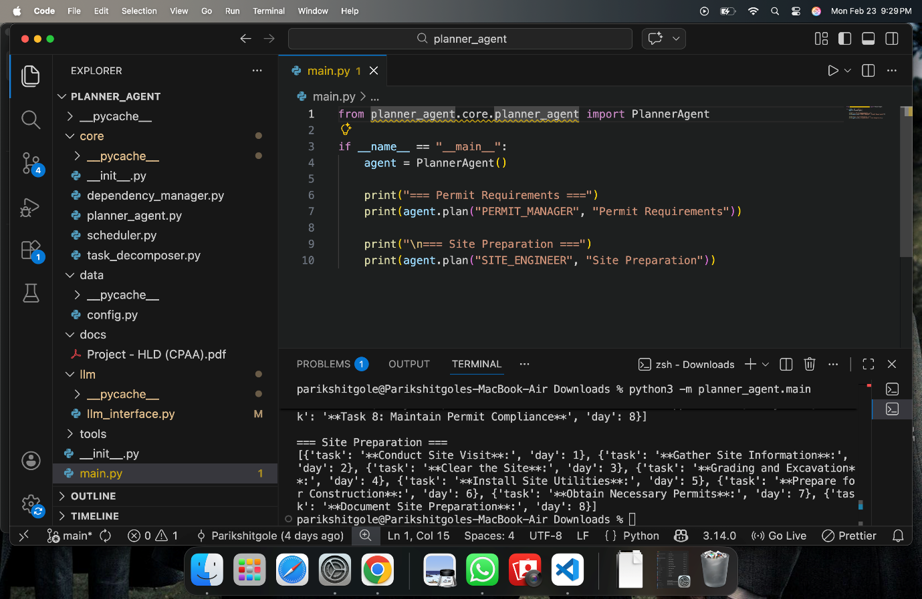

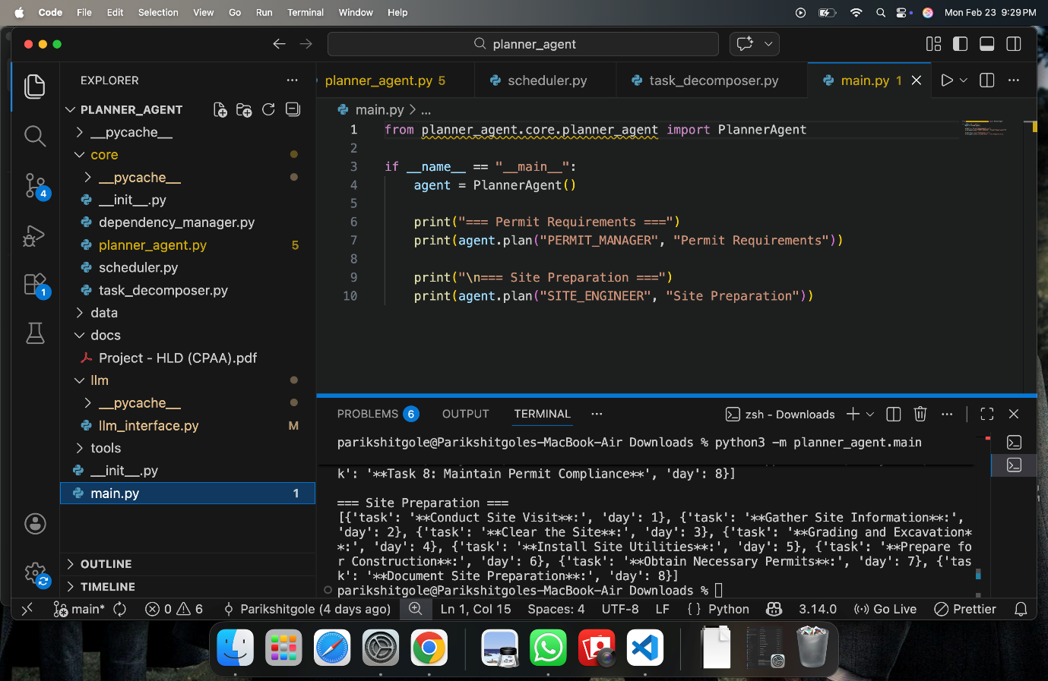
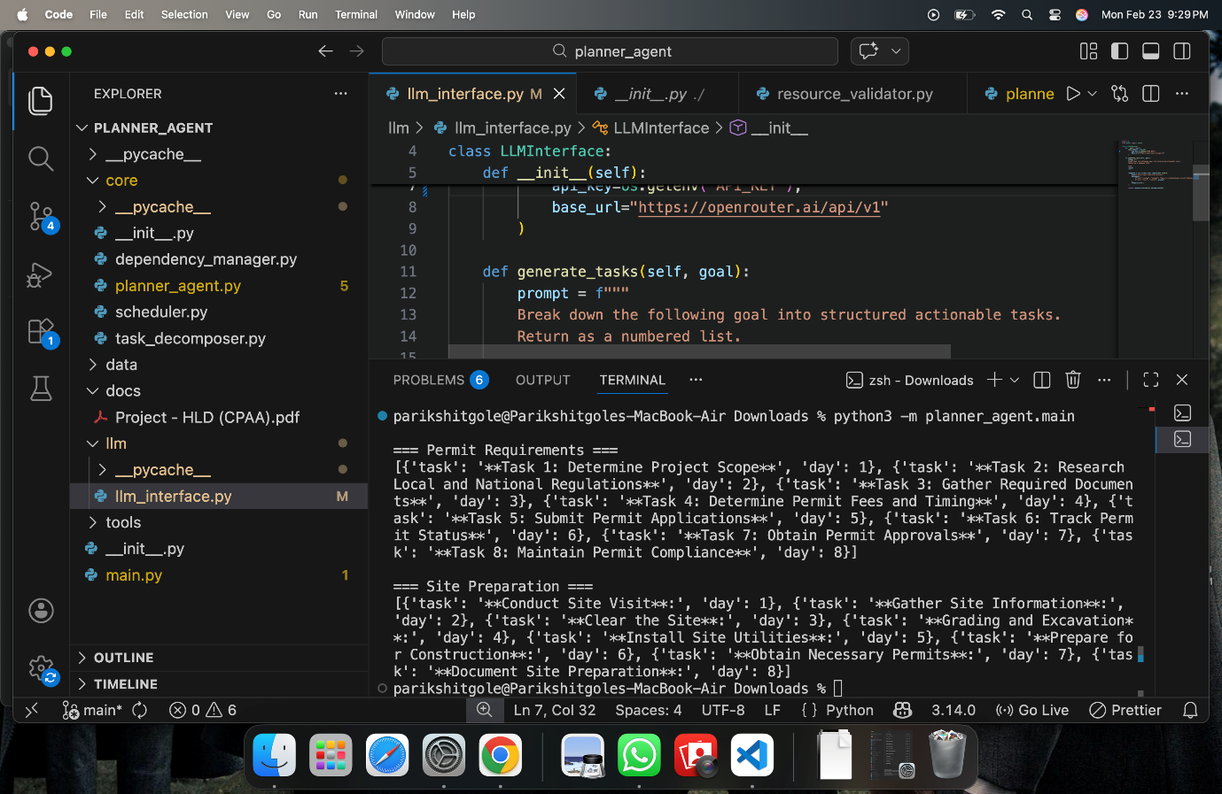
5.1 Code Execution Screenshot
Shows:
• Running the planner agent
• Command-line execution
• System initialization
5.2 AI Task Generation Screenshot
Shows:
• LLM interface code
• Prompt generation logic
• Structured task output
5.3 Planning Output Screenshot
Shows:
• Generated task lists
• Assigned timelines
• Execution order
5.4 System Architecture Code Screenshot
Shows:

• Planner agent core logic
• Module interaction
• Scheduling mechanism

6. Reports Generated by the System
The system generates structured planning reports including:
6.1 Task Planning Report
Contains:
• Task list
• Execution order
• Dependencies
6.2 Scheduling Report
Contains:
• Task timelines
• Start and end days
• Total project duration
6.3 Resource Validation Report
Contains:
• Required resources
• Availability status
• Feasibility results

7. Key Performance Observations
7.1 Planning Accuracy
• The AI successfully generated realistic construction tasks
• Task sequences followed real-world logic
• Dependencies were meaningful and correct
7.2 Processing Efficiency
• Planning was completed within seconds
• No manual intervention required
• Fast execution due to in-memory processing

7.3 System Reliability
• No runtime errors occurred during testing
• Validation modules ensured correctness
• Structured outputs prevented inconsistencies

8. Key Outcomes of the Project
8.1 Functional Achievements
• Automated construction planning successfully implemented
• AI reasoning effectively integrated
• Scheduling and validation modules worked correctly
8.2 Practical Benefits
• Reduced manual planning effort
• Improved task sequencing accuracy
• Generated feasible execution plans
8.3 Technical Achievements
• Designed modular architecture
• Implemented AI + rule-based hybrid system
• Achieved efficient data flow between modules.

⭐ACTIVITY DIAGRAM
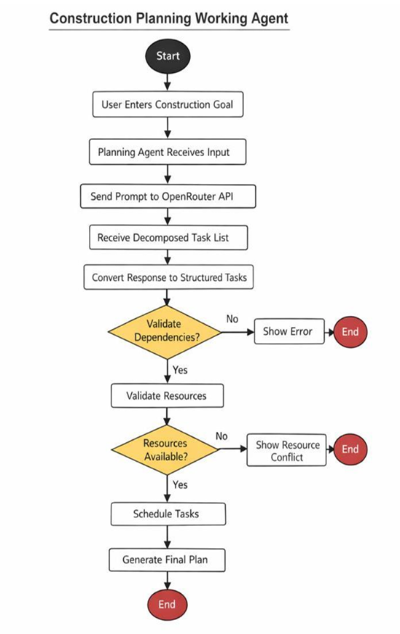

⭐ CLASS DIAGRAM
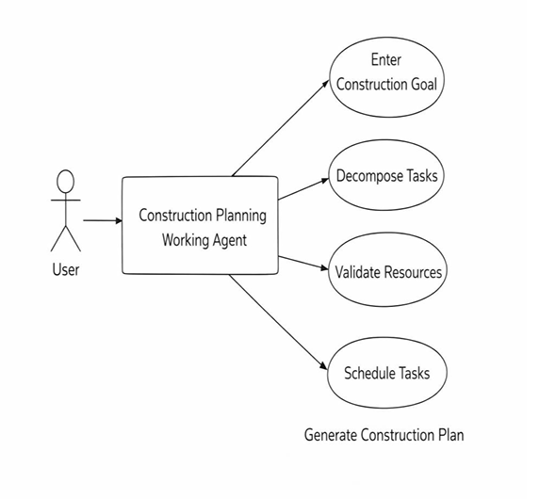
⭐ CONCLUSION
The Construction Planning Assistant Agent successfully demonstrates the practical application of artificial intelligence in the field of construction project planning. The system effectively addresses the limitations of traditional manual planning methods by introducing an automated, intelligent, and structured approach.
The project achieved its primary goal of developing a system capable of transforming high-level construction objectives into detailed execution plans. By integrating AI-based reasoning with deterministic validation modules, the system ensures both flexibility and reliability.
The Planning Agent efficiently decomposes complex goals into manageable tasks using natural language understanding. The Dependency Manager ensures logical correctness,

while the Resource Validator maintains practical feasibility. The Scheduler optimizes task timelines while respecting all constraints.
The modular architecture of the system makes it scalable, maintainable, and adaptable for future improvements. The project also highlights the importance of combining AI capabilities with rule-based engineering logic to achieve realistic and trustworthy results.
From a learning perspective, this project provided valuable experience in system architecture design, AI integration, modular programming, and real-world problem solving. It also enhanced understanding of how intelligent agents can be applied to automate complex engineering processes.
Overall, the project successfully demonstrates the potential of intelligent assistant agents in improving efficiency, accuracy, and decision-making in construction planning.

⭐ FUTURE SCOPE & ENHANCEMENTS
Although the current system provides a strong foundation for automated construction planning, several enhancements can further improve its capabilities and real-world applicability.
1. Database Integration
Future systems can include:
• Persistent storage for project data
• Historical planning records
• Multi-session project management
2. Real-Time Resource Monitoring
Enhancements may include:
• Dynamic resource tracking
• Live availability updates
• Automatic schedule adjustments
3. Cost Estimation Module
Future versions can support:
• Budget calculation
• Cost optimization algorithms
• Financial feasibility analysis

4. Risk Assessment Features
Advanced systems may include:
• Risk prediction models
• Safety compliance checking
• Hazard detection mechanisms
5. Graphical Visualization
Future enhancements may include:
• Gantt chart generation
• Interactive dashboards
• Visual workflow representation
6. Multi-Project Planning
Future systems can support:
• Simultaneous project management
• Resource sharing optimization
• Cross-project scheduling
7. Integration with IoT Systems
Possible enhancements:
• Sensor-based progress tracking
• Automated data collection
• Smart construction monitoring
8. Advanced AI Optimization
Future AI improvements may include:
• Machine learning-based scheduling
• Predictive planning models
• Adaptive decision-making algorithms
9. Web-Based Deployment
Future implementation may include:
• Cloud-based planning platform
• Multi-user access system
• Mobile application support

